Using DataSet Objects

Now that you’ve learned the basics about the ADO.NET objects, it’s time to see what you can do with them. In particular, I concentrate on some of the basic operations, including the following:

- Populating a DataSet object from a database
- Moving around in DataSet objects and retrieving data
- Using strongly typed DataSet objects
- Using DataSet objects with multiple tables
- Finding and sorting data in DataSet objects
- Editing data with ADO.NET

Populating a DataSet Object from a Database

Before you can do anything with data in a DataSet object, you have to get that data into the DataSet object somehow. In general, you can follow a four-step process to move data from the database to a DataSet object:

1. Create a SqlConnection object to connect to the database.
2. Create a SqlCommand object to retrieve the desired data.
3. Assign the SqlCommand object to the SelectCommand property of a SqlDataAdapter object.
4. Call the Fill() method of the SqlDataAdapter object.

Lab 1: Filling a DataSet Object

1. Add a new form to your Visual C# .NET project.
2. Place a Button control (btnLoad) and a DataGrid control (dgProducts) on the form. Set the Caption property of the DataGrid control to Products.
3. Switch to the code view and add the following using directives to make the ADO.NET objects available:
using System.Data;
using System.Data.SqlClient;
4. Double-click the Button control and enter this code to handle the Click event of the Button control:

private void btnLoad_Click(object sender,
System.EventArgs e)
{
// Create a SqlConnection
SqlConnection cnn = new SqlConnection(
“Data Source=(local); Initial Catalog=Northwind;” +
“ Integrated Security=SSPI”);
// Create a SqlCommand
SqlCommand cmd = cnn.CreateCommand();
cmd.CommandType = CommandType.Text;
cmd.CommandText = “SELECT * FROM Products “ +
“ ORDER BY ProductName”;

// Set up the DataAdapter and fill the DataSet
SqlDataAdapter da = new SqlDataAdapter();
da.SelectCommand = cmd;
DataSet ds = new DataSet();
da.Fill(ds, “Products”);
// Display the data on the user interface
dgProducts.DataSource = ds;
dgProducts.DataMember = “Products”;
}
5. Run the project and click the button. The code connects to the SQL Server database on the local computer and fills the DataGrid control with the result of executing the SQL statement, as shown in Figure 1.

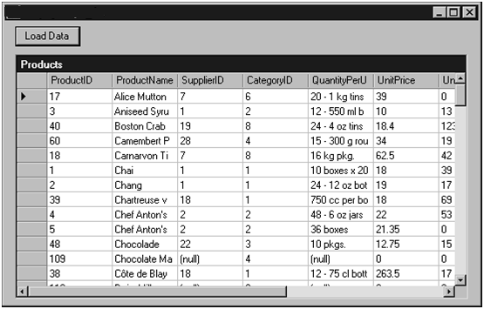
FIGURE 1
You can bind a DataGrid control to data stored in a data set.

Lab 1 demonstrates a couple shortcuts that you can use in your ADO.NET code. First, the constructor for the SqlConnection object has an overloaded form that lets you supply the connection string when you create the object. Second, this code doesn’t explicitly call the Open() and Close() methods of the SqlConnection object. Instead, it lets the SqlDataAdapter object make those calls when it needs the data. Doing this not only cuts down the amount of code you need to write, but it also improves the scalability of your application by keeping the SqlConnection object open for the shortest possible period of time.

Moving Around in DataSet Objects and Retrieving Data

If you’re familiar with classic ADO, you’re used to recordsets: collections of records that have a pointer to the current record. DataSet objects have no concept of a current record pointer. Instead, you move through a DataSet object by working with the collections that the DataSet contains.

Lab 2: Moving Through a DataSet Object

1. Add a new form to your Visual C# .NET project.
2. Place a Button control (btnLoadData) and a ListBox control (lbData) on the form.
3. Switch to the code view and add the following usingdirectives to make the ADO.NET objects available:
using System.Data;
using System.Data.SqlClient;
4. Double-click the Button control and enter this code to handle the Click event of the Button control:

private void btnLoadData_Click(object sender,
System.EventArgs e)
{
// Create a SqlConnection
SqlConnection cnn = new SqlConnection(
“Data Source=(local);
Initial Catalog=Northwind;” +
“ Integrated Security=SSPI”);
// Create a SqlCommand
SqlCommand cmd = cnn.CreateCommand();
cmd.CommandType = CommandType.Text;
cmd.CommandText = “SELECT * FROM Customers “ +
“ WHERE Country = ‘France’”;
// Set up the DataAdapter and fill the DataSet
SqlDataAdapter da = new SqlDataAdapter();
da.SelectCommand = cmd;
DataSet ds = new DataSet();
da.Fill(ds, “Customers”);
// Dump the contents of the DataSet
lbData.Items.Add(“DataSet: “ + ds.DataSetName);
foreach (DataTable dt in ds.Tables)
{
lbData.Items.Add(“ DataTable: “ +
dt.TableName);
foreach (DataRow dr in dt.Rows)
{
lbData.Items.Add(“ DataRow”);
foreach (DataColumn dc in dt.Columns)
{
lbData.Items.Add(“ “ + dr[dc]);
}
}
}
}

5. Run the project and click the button. The code dumps the contents of the DataSet object to the ListBox control, as shown in Figure 2.

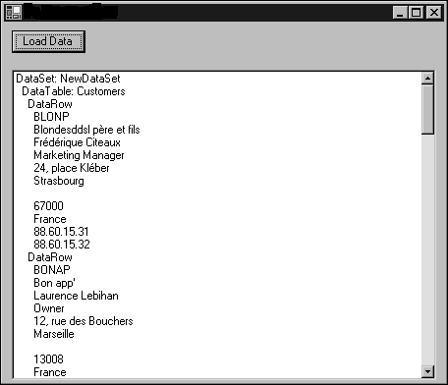
FIGURE 2
You can dump the contents of a DataSet object to a ListBox control.

Lab 2 shows how you can visit every piece of data in a DataSet object by properly selecting nested foreach loops. It also shows a general syntax for retrieving data: Locate the DataRow and DataColumn objects whose intersection contains the data that you’re interested in, and use the dr[dc] indexer syntax to retrieve the actual data value. There are a variety of other syntaxes that you can use to retrieve data. Given a DataTable variable named dt that refers to the data from the Customers table, for example, either of these statements would retrieve the value in the first column of the first row of data in the DataTable object:

dt.Rows[0][0]
dt.Rows[0][“CustomerID”]

Using Strongly Typed DataSet Objects

All the syntaxes shown in the previous section for retrieving data have one thing in common: They’re all late-bound. That is, the .NET Framework doesn’t know until runtime that CustomerID is a valid column name. One of the innovations of ADO.NET is a provision to create strongly typed DataSet objects. In a strongly typed DataSet object, columns actually become properties of the row. This allows you to write an early-bound version of the data-retrieval expression:

dt.Rows[0].CustomerID

In addition to being faster than the late-bound syntaxes, the earlybound syntax has the added advantage of making column names show up in IntelliSense tips as you type code.
You’ve already seen quite a few strongly typed DataSet objects, although I didn’t emphasize this while I was using them. Any time that you use the Generate DataSet link in the Properties window for a SqlDataAdapter object on a form, Visual Studio .NET builds a strongly typed DataSet object. You can also build strongly typed DataSet objects by using the XSD designer.

Lab 3: Designing a Strongly Typed DataSet Object

1. Select Project, Add New Item in your Visual C# .NET project.
2. In the Add New Item dialog box, select the DataSet template. Name the new DataSet SuppliersDataSet.xsd.
Click Open to create the XSD file and open it in the XSD designer.
3. Open Server Explorer.
4. Expand the tree under Data Connections to show a SQL Server data connection that points to the Northwind sample database, and then expand the Tables node of the selected SQL Server data connection. Drag the Suppliers table from Server Explorer and drop it on the design surface for the DataSet object. Figure 3 shows the resulting XSD design view. The E icons for each column of the table indicate that those columns have been rendered as XML elements.
5. Save the DataSet object. At this point, your project should contain a new class named SuppliersDataSet, which is a strongly typed DataSet object that you can use in code.
6. Add a new form to your Visual C# .NET project.
7. Place a Button control (btnLoadData) and a ListBox control (lbData) on the form.

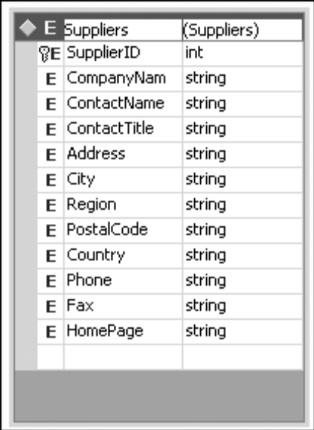
FIGURE 3-1
You can create strongly typed DataSet objects in the XSD designer of Visual Studio .NET.

8. Switch to the code view and add the following using directives to make the ADO.NET objects available:
using System.Data;
using System.Data.SqlClient;
9. Double-click the Button control and enter this code to handle the Click event of the Button control:
private void btnLoadData_Click(object sender,
System.EventArgs e)
{
// Create a SqlConnection
SqlConnection cnn = new SqlConnection(
“Data Source=(local); Initial Catalog=Northwind;” +
“ Integrated Security=SSPI”);
// Create a SqlCommand
SqlCommand cmd = cnn.CreateCommand();
cmd.CommandType = CommandType.Text;
cmd.CommandText = “SELECT * FROM Suppliers”;
// Set up the DataAdapter and fill the DataSet
SqlDataAdapter da = new SqlDataAdapter();
da.SelectCommand = cmd;
SuppliersDataSet ds = new SuppliersDataSet();
da.Fill(ds, “Suppliers”);
// Dump the contents of the DataSet
foreach (SuppliersDataSet.SuppliersRow suppRow
in ds.Suppliers)
{
lbData.Items.Add(suppRow.SupplierID +
“ “ + suppRow.CompanyName);
}
}
10. Run the project and click the button. The code displays two columns from the DataSet object in the ListBox control, as shown in Figure 3-2
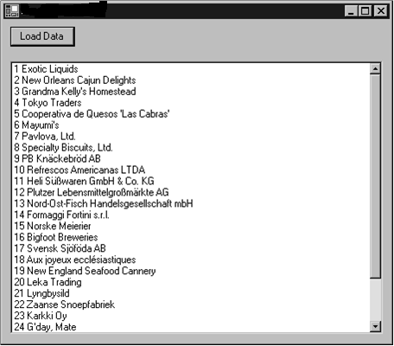
FIGURE 3-2
A strongly typed DataSet object allows you to create early-bound data retrieval expressions.
Using the SuppliersDataSet class to define the DataSet object in this case gives you several syntactical benefits. You can refer to the Suppliers DataTable object as a property of the DataSet object. You can also refer to the columns in the DataRow objects in this DataTable object as properties of the DataRow object. The strongly typed DataSet object automatically defines a class named SuppliersRow to represent one DataRow object with strong typing.

Using DataSet Objects with Multiple Tables

Every DataSet object that you’ve seen so far has contained a single DataTable object. But a DataSet object is not limited to a single DataTable object; in fact, there’s no practical limit on the number of DataTable objects that a DataSet object can contain. By using DataAdapter objects, you can connect a single DataSet object to more than one table in the SQL Server database. You can also define DataRelation objects to represent the relationship between the DataTable objects in the DataSet object.

Lab 4: Building a DataSet Object That Contains Multiple DataTable Objects

1. Add a new form to your Visual C# .NET project.
2. Place a Button control (btnLoadData) and a DataGrid control (dgMain) on the form.
3. Switch to the code view and add the following using directives to make the ADO.NET objects available:
using System.Data;
using System.Data.SqlClient;
4. Double-click the Button control and enter this code to handle the Click event of the Button control:
private void btnLoadData_Click(object sender,
System.EventArgs e)
{
// Create a SqlConnection and a DataSet
SqlConnection cnn = new SqlConnection(
“Data Source=(local); Initial Catalog=Northwind;” +
“ Integrated Security=SSPI”);
DataSet ds = new DataSet();
// Add the customers data to the DataSet
SqlCommand cmdCustomers= cnn.CreateCommand();
cmdCustomers.CommandType = CommandType.Text;
cmdCustomers.CommandText = “SELECT * FROM Customers”;
SqlDataAdapter daCustomers = new SqlDataAdapter();
daCustomers.SelectCommand = cmdCustomers;
daCustomers.Fill(ds, “Customers”);
// Add the Orders data to the DataSet
SqlCommand cmdOrders = cnn.CreateCommand();
cmdOrders.CommandType = CommandType.Text;
cmdOrders.CommandText = “SELECT * FROM Orders”;
SqlDataAdapter daOrders = new SqlDataAdapter();
daOrders.SelectCommand = cmdOrders;
daOrders.Fill(ds, “Orders”);
// Add the Order Details data to the DataSet
SqlCommand cmdOrderDetails = cnn.CreateCommand();
cmdOrderDetails.CommandType = CommandType.Text;
cmdOrderDetails.CommandText =
“SELECT * FROM [Order Details]”;
SqlDataAdapter daOrderDetails =
new SqlDataAdapter();
daOrderDetails.SelectCommand = cmdOrderDetails;
daOrderDetails.Fill(ds, “OrderDetails”);
// Add Relations
DataRelation relCustOrder = ds.Relations.Add(
“CustOrder”,
ds.Tables[“Customers”].Columns[“CustomerID”],
ds.Tables[“Orders”].Columns[“CustomerID”]);
DataRelation relOrderOrderDetails =
ds.Relations.Add(
“OrderOrderDetails”,
ds.Tables[“Orders”].Columns[“OrderID”],
ds.Tables[“OrderDetails”].Columns[“OrderID”]);
// And show the data on the user interface
dgMain.DataSource = ds;
dgMain.DataMember = “Customers”;
}
5. Run the project and click the button. The code loads all three database tables into the DataSet object, and then it displays the customers’ information on the data grid, as shown in Figure 4-1.

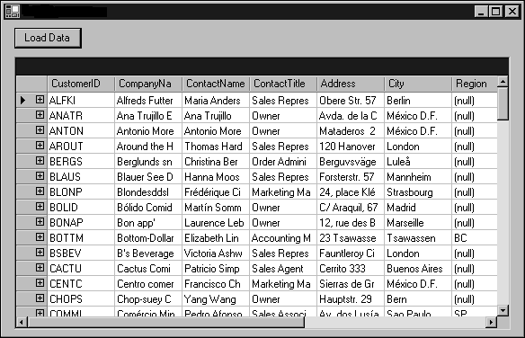
FIGURE 4-1
A DataGrid control can be bound to multiple tables of a DataSet object.

The code in Lab 4 uses three different SqlDataAdapter objects to move data from three different database tables into a single DataSet object. The data from each SqlDataAdapter object is stored in a separate DataTable object. You could also use a single SqlDataAdapter object for the same purpose, by changing its SelectCommand property each time you want to load a separate table.
The code then adds DataRelation objects to specify the relationships between these DataTable objects. The Add() method of the DataSet.Relations collection takes three parameters:

- A name for the DataRelation object to be created
- A DataColumn object that represents the primary key side of the relationship
- A DataColumn object that represents the foreign key side of the relationship

Although the DataGrid control initially displays only the customers data, all the data is available. The DataGrid control contains built-in logic to help navigate between related DataTable objects in a DataSet object. If you click the + sign to the left of a row of customer data, the DataGrid control shows a list of the relationships that involve that row, as shown in Figure 4-2.
The relationship is called a hotlink. Clicking the link loads all the related rows on the other side of that relationship into the DataGrid control, as shown in Figure 4-3. Note that the parent rows area of the DataGrid control contains information on the customer row where the navigation started.
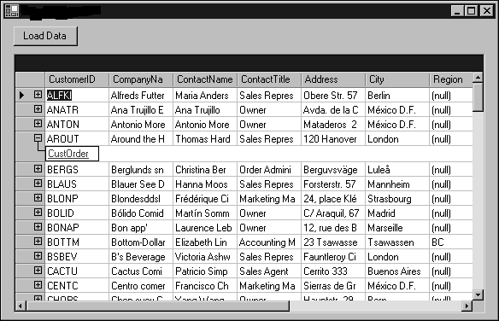

FIGURE 4-2
When the DataGrid control is bound to a DataSet object that contains multiple related tables, it displays the relationship when a row node is clicked.

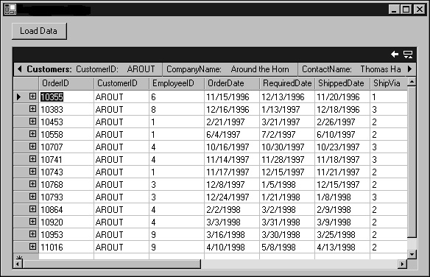
FIGURE 4-3
You can view the child table’s data in a DataGrid control when the relationship link is clicked.

Because this DataSet object has another level of detail, you can repeat the process. Click the + sign next to an order to see the relationships in which that order is involved, as shown in Figure 4-4.

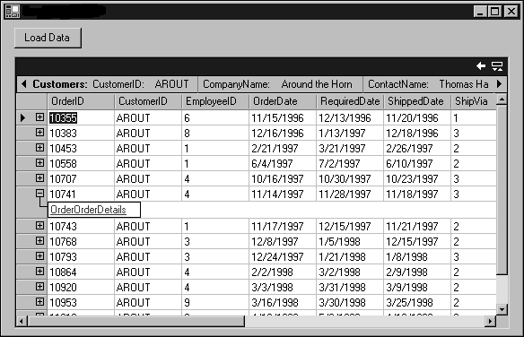
FIGURE 4-4
When a DataGrid control is bound to a DataSet object that contains multiple related tables, it allows you to drill into the details.

Finally, clicking the hotlink beneath an order reveals all the order detail rows for that order, as shown in Figure 4-5. The parent rows area contains details on both the customer and the order that were used to get to this point.

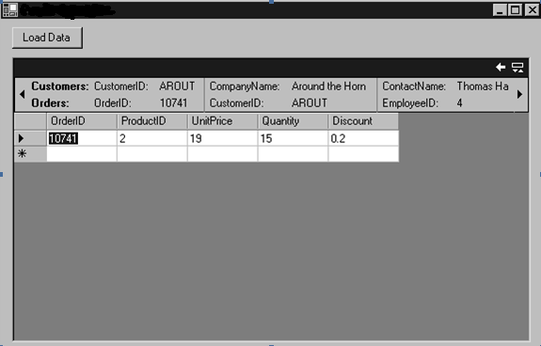
FIGURE 4-5
The parent rows area of the DataGrid control contains information from the Customers and the Orders tables.

Finding and Sorting Data in DataSet Objects

The .NET Framework offers several object-oriented ways to find and sort data. In this section, I’ll show you how to use two of these ways: by using the DataTable.Select() method and by using the filtering
and sorting capabilities of the DataView object.
Using the Select() method of the DataTable object is a convenient way to find particular DataRow objects within the DataTable object.
This method extracts an array of DataRow objects that you can work with.

Lab 5: Using the DataTable.Select() Method

1. Add a new form to your Visual C# .NET project.
2. Place a Button control (btnSelect), a TextBox control (txtCountry), and a ListBox control (lbSelected) on the form.
3. Switch to the code view and add the following using directives to make the ADO.NET objects available:
using System.Data;
using System.Data.SqlClient;

4. Double-click the Button control and enter this code to handle the Click event of the Button control:
private void btnSelect_Click(object sender,
System.EventArgs e)
{
// Create a SqlConnection
SqlConnection cnn = new SqlConnection(
“Data Source=(local); Initial Catalog=Northwind;” +
“ Integrated Security=SSPI”);
// Create a SqlCommand
SqlCommand cmd = cnn.CreateCommand();
cmd.CommandType = CommandType.Text;
cmd.CommandText = “SELECT * FROM Customers”;
// Set up the DataAdapter and fill the DataSet
SqlDataAdapter da = new SqlDataAdapter();
da.SelectCommand = cmd;
DataSet ds = new DataSet();
da.Fill(ds, “Customers”);
// Use the Select method
// To get a sorted array of DataRow objects
DataRow[] adr = ds.Tables[“Customers”].Select(
“Country = ‘“ + txtCountry.Text + “‘“,
“ContactName ASC”);
// Dump the result to the user interface
lbSelected.Items.Clear();
foreach(DataRow dr in adr)
{
lbSelected.Items.Add(dr[0] + “ “ + dr[1] +
“ “ + dr[2]);
}
}
5. Run the project. Enter a country name and click the button. You see the first three columns from the DataRow objects for customers in that country, as shown in Figure 5.

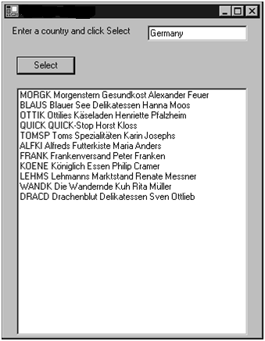
FIGURE 5
The DataTable.Select() method allows you to select a collection of rows that are sorted by a given sort expression and that match a given filter expression.

The Select() method of the DataTable object constructs an array of DataRow objects, based on up to three factors: a filter expression, a sort expression, and a state constant.
Filter expressions are essentially SQL WHERE clauses that are constructed according to these rules:

- Column names containing special characters should be enclosed in square brackets.
- String constants should be enclosed in single quotes.
- Date constants should be enclosed in pound signs.
- Numeric expressions can be specified in decimal or scientific notation.
- Expressions can be created by using AND, OR, NOT, parentheses, IN, LIKE, comparison operators, and arithmetic operators.
- The + operator is used to concatenate strings.
- Either * or % can be used as a wildcard to match any number of characters. A wildcard can be used only at the start or end of a string.
- Columns in a child table can be referenced with the expression Child.Column. If the table has more than one child table, you use the expression Child(RelationName).Column to choose a particular child table.
- The Sum, Avg, Min, Max, Count, StDev, and Var aggregates can be used with child tables.
- Supported functions include CONVERT, LEN, ISNULL, IIF, and SUBSTRING.

In the code in Lab 5, the filter expression is built by concatenating the text from the txtCountry control with a column comparison.
If you don’t specify a sort order in the Select() method, the rows are returned in primary key order or in the order of addition, if the table doesn’t have a primary key. You can also specify a sort expression that consists of one or more column names and the keywords ASC or DESC to specify ascending or descending sorts. For example, this is a valid sort expression:
Country ASC, CompanyName DESC
This expression sorts first by country, in ascending order, and then by company name within each country, in descending order.
Finally, you can also select DataRow objects according to their current state by supplying one of the DataViewRowState constants. The following table shows these constants.

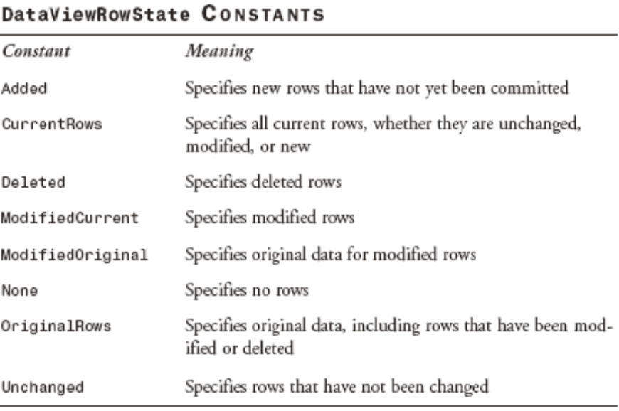

You can also sort and filter data by using a DataView object. The DataView object has the same structure of rows and columns as a DataTable object, but it also lets you specify sorting and filtering options as properties of the DataView object. Typically you create a DataView object by starting with a DataTable object and specifying options to include a subset of the rows in the DataTable object.

Lab 6: Using a DataView Object to Sort and Filter Data

1. Add a new form to your Visual C# .NET project.
2. Place a Button control (btnLoad) and a DataGrid control (dgCustomers) on the form.
3. Switch to the code view and add the following using directives to make the ADO.NET objects available:
using System.Data;
using System.Data.SqlClient;

4. Double-click the Button control and enter this code to handle the Click event of the Button control:
private void btnLoad_Click(object sender,
System.EventArgs e)
{
// Create a SqlConnection
SqlConnection cnn = new SqlConnection(
“Data Source=(local); Initial Catalog=Northwind;” +
“ Integrated Security=SSPI”);
// Create a SqlCommand
SqlCommand cmd = cnn.CreateCommand();
cmd.CommandType = CommandType.Text;
cmd.CommandText = “SELECT * FROM Customers”;
// Set up the DataAdapter and fill the DataSet
SqlDataAdapter da = new SqlDataAdapter();
da.SelectCommand = cmd;
DataSet ds = new DataSet();
da.Fill(ds, “Customers”);
// Create a DataView based on the Customers DataTable
DataView dv = new DataView(ds.Tables[“Customers”]);
dv.RowFilter = “Country = ‘France’”;
dv.Sort = “CompanyName ASC”;
dgCustomers.DataSource = dv;
}
5. Run the project and click the button. The DataGrid control displays only the customers from France, sorted in ascending order by column CompanyName.
The constructor for the DataView object in Lab 6 specifies the DataTable object that includes the data from which the DataView object can draw. By setting the RowFilter, Sort, and RowStateFilter properties of the DataView object, you can control which rows are available in the DataView object, as well as the order in which they are presented. I don’t use the RowStateFilter property in Lab 6; RowStateFilter allows you to select, for example, only rows that have been changed since the DataTable object was loaded.

Lab 7:

In this lab, you fill a DataSet object with customer and order data. Then you allow the user to select a customer and display a DataView object that contains only that customer’s orders on the user interface.
Your form should include a bound ComboBox control to allow the user to select a CustomerID value. When the user selects a new value in the combo box, you should initialize the DataView object and bind it to a DataGrid control for display.
How would you create such a form?
You should try working through this problem on your own first. If you get stuck, or if you’d like to see one possible solution, follow these steps:
1. Add a new form to your Visual C# .NET project.
2. Add a Label control, a ComboBox control (cboCustomers), and a DataGrid control (dgOrders) to the form. Figure 7 shows a possible design for the form.
3. Switch to the code view and add the following using directives to make the ADO.NET objects available:
using System.Data;
using System.Data.SqlClient;
4. Add the following code to the class definition:
// Create a SqlConnection
SqlConnection cnn = new SqlConnection(
“Data Source=(local); Initial Catalog=Northwind;” +
“ Integrated Security=SSPI”);
// DataSet to hold order information
DataSet dsOrders = new DataSet();

5. Double-click the form to attach an event handler to its Load event. Enter the following code to fill the list in the ComboBox control and initialize a DataSet object of orders in the event handler:

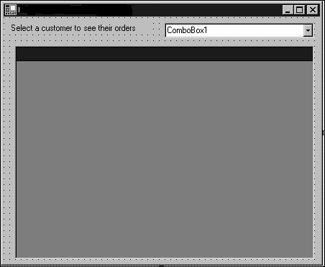
Lab 7
This form can retrieve order information by customer.

private void Lab7_Load(
object sender,System.EventArgs e)
{

// Get all of the orders
SqlCommand cmdOrders = cnn.CreateCommand();
cmdOrders.CommandType = CommandType.Text;
cmdOrders.CommandText = “SELECT * FROM Orders”;
SqlDataAdapter daOrders = new SqlDataAdapter();
daOrders.SelectCommand = cmdOrders;
daOrders.Fill(dsOrders, “Orders”);
// Retrieve data for the combo box
SqlCommand cmdCustomers = cnn.CreateCommand();
cmdCustomers.CommandType = CommandType.Text;
cmdCustomers.CommandText = “SELECT CustomerID, “ +
“ CompanyName FROM Customers ORDER BY CompanyName”;
DataSet ds = new DataSet();
SqlDataAdapter da = new SqlDataAdapter();
da.SelectCommand = cmdCustomers;
da.Fill(ds, “Customers”);
cboCustomers.DisplayMember = “CompanyName”;
cboCustomers.ValueMember = “CustomerID”;
cboCustomers.DataSource = ds.Tables[“Customers”];
}
6. Attach SelectedIndexChanged event handler to the combo box. Enter this code to load the correct orders when a value is selected from the combo box:

private void cboCustomers_SelectedIndexChanged(
object sender, System.EventArgs e)
{
// Create a DataView object
// Containing the orders for the selected customer
DataView dv = new DataView(
dsOrders.Tables[“Orders”]);
dv.RowFilter = “CustomerID = ‘“ +
cboCustomers.SelectedValue + “‘“;
dgOrders.DataSource = dv;
}

7. Run the project. Select a customer from the combo box. That customer’s order is displayed in the data grid.

Editing Data with ADO.NET

Now that you know how to retrieve data with ADO.NET, there’s one other important database-related topic to cover: editing data.
ADO.NET supports all the normal database operations of updating existing data, adding new data, and deleting existing data.
As you read the following sections, you need to keep in mind the distinction between the data model and the database. As you work with data in the DataSet object and its subsidiary objects, you alter the data in the data model. These changes are not reflected in the underlying database until and unless you call the Update() method of the SqlDataAdapter object. So far I’ve only been using SqlDataAdapter to move data from the database to the data model; in the following sections, you’ll see how to move data back from the data model to the database.

Updating Data
Updating data is easy: You simply assign a new value to the item in the DataRow object that you want to change. But there’s more to finishing the job. In order for the Update() method of the SqlDataAdapter object to write changes back to the database, you need to set its UpdateCommand property to an appropriate SqlCommand object. Lab 8 shows you how.

Lab 8: Using a SqlDataAdapter Object to Update Data in a Database

1. Add a new form to your Visual C# .NET project.
2. Place two Label controls, one ComboBox control (cboCustomerID), one TextBox control (txtContactName), and a Button control (btnAdd) on the form. Figure 8 shows the design for the form.
3. Switch to the code view and add the following using directives to make the ADO.NET objects available:
using System.Data;
using System.Data.SqlClient;
4. Add the following code in the class definition:
// Create SqlConnection, DataSet, SqlDataAdapter
// And DataRow[] ADO.NET objects
SqlConnection cnn = new SqlConnection(
“Data Source=(local); Initial Catalog=Northwind;” +
“ Integrated Security=SSPI”);
DataSet ds = new DataSet();
SqlDataAdapter da = new SqlDataAdapter();
DataRow[] adrEdit;

5. Double-click the form and enter this code to load data when the form is opened:
private void Lab8_Load(object sender,
System.EventArgs e)
{
// Create a SqlCommand to select data
SqlCommand cmdSelect = cnn.CreateCommand();
cmdSelect.CommandType = CommandType.Text;
cmdSelect.CommandText =
“SELECT CustomerID, ContactName FROM Customers”;
// Create a SqlCommand to update data
SqlCommand cmdUpdate = cnn.CreateCommand();
cmdUpdate.CommandType = CommandType.Text;
cmdUpdate.CommandText = “UPDATE Customers SET “ +
“ContactName = @ContactName “ +
“ WHERE CustomerID = @CustomerID”;
cmdUpdate.Parameters.Add(“@ContactName”,
SqlDbType.NVarChar,30, “ContactName”);
cmdUpdate.Parameters.Add(“@CustomerID”,
SqlDbType.NChar,5, “CustomerID”);

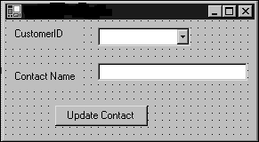
FIGURE 8
You can update the data in a database by using a SqlDataAdapter object.

cmdUpdate.Parameters[“@CustomerID”].SourceVersion =
DataRowVersion.Original;
// Set up the DataAdapter and fill the DataSet
da.UpdateCommand = cmdUpdate;
da.SelectCommand = cmdSelect;
da.Fill(ds, “Customers”);
// Fill the data in the ComboBox
cboCustomerID.DisplayMember = “CustomerID”;
cboCustomerID.ValueMember = “CustomerID”;
cboCustomerID.DataSource = ds.Tables[“Customers”];
}
6. Double-click the ComboBox control and enter this code to handle the SelectedIndexChanged event:
private void cboCustomerID_SelectedIndexChanged(
object sender, System.EventArgs e)
{
// Get just that customer’s DataRow
adrEdit = ds.Tables[“Customers”].Select(
“CustomerID = ‘“ +
cboCustomerID.SelectedValue + “‘“);
// Make sure there’s some data
if (adrEdit != null)
{
txtContactName.Text =
adrEdit[0][“ContactName”].ToString();
}
}
7. Double-click the Button control and enter this code to handle the Click event of the Button control:
private void btnUpdate_Click(object sender,
System.EventArgs e)
{
// Make sure there’s some data
if (adrEdit != null)
{
// Prompt for new data and
// put it in the DataRow object
adrEdit[0][“ContactName”] = txtContactName.Text;
// And save the changes
da.Update(ds, “Customers”);
MessageBox.Show(“Contact Name Updated!”);
}
}

8. Run the project. The code displays all the Customer ID values in the ComboBox control, with the corresponding contact name value from the database in the text box.
Select a customer ID (such as ALFKI) from the combo box and update the text box with a new contact name. Click the button. The change is written back to the database, and the update message is displayed in a message box.
The Update() method of the SqlDataAdapter object is syntactically similar to the Fill() method. It takes as its parameters the DataSet object to be reconciled with the database and the name of the DataTable object to be saved. You don’t have to worry about which rows or columns of data are changed. The SqlDataAdapter object automatically locates the changed rows. It executes the SqlCommand object specified in its UpdateCommand property for each of those rows.
In Lab 8, the UpdateCommand property has two parameters. The SqlParameter objects are created by using a version of the constructor that takes four parameters. The fourth parameter is the name of a
DataColumn that contains the data to be used in this particular parameter.
Note also that you can specify whether a parameter should be filled in from the current data in the DataSet object (the default) or the original version of the data, before any edits were made. In this case, the @CustomerID parameter is being used to locate the row to edit in the database, so the code uses the original value of the column as the value for the parameter.

Adding Data

To add data to the database, you must supply a SqlCommand object for the InsertCommand property of the SqlDataAdapter object.

Lab 9: Using a SqlDataAdapter Object to Add Data to a Database

1. Add a new form to your Visual C# .NET project.
2. Place four Label controls, three TextBox controls (txtCustomerID, txtCompanyName, and txtContactName), and a Button control (btnAdd) on the form. Figure 9 shows the design for the form.
3. Switch to the code view and add the following using directives to make the ADO.NET objects available:
using System.Data;
using System.Data.SqlClient;
4. Double-click the form and enter this code to load data when the form is opened:
// Create some ADO.NET objects
SqlConnection cnn = new SqlConnection(
“Data Source=(local); Initial Catalog=Northwind;” +
“ Integrated Security=SSPI”);
DataSet ds = new DataSet();
SqlDataAdapter da = new SqlDataAdapter();
private void Lab9_Load(object sender,
System.EventArgs e)
{
// Create a SqlCommand to select data
SqlCommand cmdSelect = cnn.CreateCommand();
cmdSelect.CommandType = CommandType.Text;
cmdSelect.CommandText =
“SELECT CustomerID, CompanyName, “ +
“ContactName FROM Customers”;
// Create a SqlCommand to insert data
SqlCommand cmdInsert = cnn.CreateCommand();
cmdInsert.CommandType = CommandType.Text;
cmdInsert.CommandText = “INSERT INTO Customers “ +
“(CustomerID, CompanyName, ContactName) “ +
“VALUES(@CustomerID, @CompanyName, @ContactName)”;
cmdInsert.Parameters.Add(“@CustomerID”,
SqlDbType.NChar,5, “CustomerID”);
cmdInsert.Parameters.Add(“@CompanyName”,
SqlDbType.NVarChar,40, “CompanyName”);
cmdInsert.Parameters.Add(“@ContactName”,
SqlDbType.NVarChar,30, “ContactName”);
cmdInsert.Parameters[“@CustomerID”].SourceVersion =
DataRowVersion.Original;

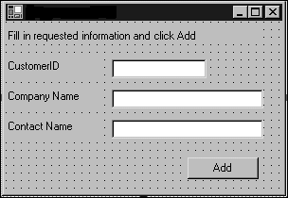
FIGURE 9
You can use the InsertCommand property of the SqlDataAdapter object to insert new customers into a database.

// Set up the DataAdapter and fill the DataSet
da.SelectCommand = cmdSelect;
da.InsertCommand = cmdInsert;
da.Fill(ds, “Customers”);
}
5. Double-click the Button control and enter this code to handle the Click event of the Button control:
private void btnAdd_Click(object sender,
System.EventArgs e)
{
// Create a new DataRow
DataRow dr = ds.Tables[“Customers”].NewRow();
// Set values
dr[0] = txtCustomerID.Text;
dr[1] = txtCompanyName.Text;
dr[2] = txtContactName.Text;
// And append the new row to the DataTable
ds.Tables[“Customers”].Rows.Add(dr);
// Now save back to the database
da.Update(ds, “Customers”);
MessageBox.Show(“Row added!”);
}
6. Run the project. Enter data in the TextBox controls and click the button. The code adds the new row to the database.
As you can see from Lab 9, the process of adding a new DataRow object to a DataTable object has several steps. First, you call the NewRow() method of the DataTable object. This returns a DataRow object that has the proper schema for that particular DataTable object. Then you can set the values of the individual items in the DataRow object. Finally, you call the Add() method of the DataTable object to actually append this DataRow object to the DataTable object.
Of course, appending the DataRow object to the DataTable object doesn’t make any changes to the database. For that, you need to call the Update() method of the SqlDataAdapter object once again. If the
SqlDataAdapter object finds any new rows in its scan of the database, it calls the SqlCommand object specified by its InsertCommand property once for each new row. This SqlCommand object does the actual work of permanently saving the data.

Deleting Data

The DataRow object supports a Delete() method that deletes an entire DataRow object from the DataTable object. To cause the changes to the database to persist, you need to call the Update() method of the SqlDataAdapter object.

Lab 10: Using a SqlDataAdapter Object to Delete Data from a Database

1. Add a new form to your Visual C# .NET project.
2. Place a Label control, a ComboBox control (cboCustomerID) and a Button control (btnDelete) on the form.
3. Switch to the code view and add the following using directives to make the ADO.NET objects available:
using System.Data;
using System.Data.SqlClient;
4. Double-click the form and enter this code to load data when the form is opened:
// Create some ADO.NET objects
SqlConnection cnn = new SqlConnection(
“Data Source=(local); Initial Catalog=Northwind;” +
“ Integrated Security=SSPI”);
DataSet ds = new DataSet();
SqlDataAdapter da = new SqlDataAdapter();
private void Lab10_Load(object sender,
System.EventArgs e)
{
// Create a SqlCommand to select data
SqlCommand cmdSelect = cnn.CreateCommand();
cmdSelect.CommandType = CommandType.Text;
cmdSelect.CommandText =
“SELECT CustomerID, ContactName FROM Customers”;
// Create a SqlCommand to delete data
SqlCommand cmdDelete = cnn.CreateCommand();
cmdDelete.CommandType = CommandType.Text;
cmdDelete.CommandText =
“DELETE FROM Customers " +
WHERE CustomerID = @CustomerID”;
cmdDelete.Parameters.Add(“@CustomerID”,
SqlDbType.NChar,5, “CustomerID”);
cmdDelete.Parameters[“@CustomerID”].SourceVersion =
DataRowVersion.Original;
// Set up the DataAdapter and fill the DataSet
da.SelectCommand = cmdSelect;
da.DeleteCommand = cmdDelete;
da.Fill(ds, “Customers”);
// Fill the data in the ComboBox
cboCustomerID.DisplayMember = “CustomerID”;
cboCustomerID.ValueMember = “CustomerID”;
cboCustomerID.DataSource = ds.Tables[“Customers”];
}
5. Double-click the Button control and enter this code to handle the Click event of the Button control:
private void btnDelete_Click(object sender,
System.EventArgs e)
{
// Find the specified row and delete it
foreach( DataRow dr in ds.Tables[“Customers”].Rows)
{
if(dr[0] == cboCustomerID.SelectedValue)
{
dr.Delete();
break;
}
}
// Save the changes
da.Update(ds, “Customers”);
MessageBox.Show(“Row deleted!”);
}
6. Run the project. The form pops up with a ComboBox control that contains all the customer IDs and a Button control. Select a customer ID and click the button. The selected customer is deleted from the DataSet object and from the database.
Note in Lab 10 that the deletion command uses the original value of the CustomerID column to locate the correct row to delete from the database.

Editing with a DataGrid Control

The preceding examples of editing, adding, and deleting rows are functional but somewhat tedious. Fortunately, there are easier ways to set up these operations in the user interface. If you bind a DataSet object to a DataGrid control, the DataGrid control enables you to perform all three of the fundamental editing operations:

- To update the data in a row, click in the column to be updated and type a new value.
- To add a new row, scroll to the end of the list and type the values for the row into the last row of the DataGrid control.
- To delete a row, click on the record selector to the left of the row and click the Delete key on the keyboard.

If you use a DataGrid control for editing, you should supply SqlCommand objects to handle all the editing operations.

Lab 11: Using a DataGrid Control to Edit Data in a Database

1. Add a new form to your Visual C# .NET project.
2. Place a DataGrid control (dgCustomers) and a Button control (btnSaveChanges) on the form.
3. Switch to the code view and add the following using directives to make the ADO.NET objects available:
using System.Data;
using System.Data.SqlClient;
4. Double-click the form and enter this code to load data when the form is opened:
// Create some ADO.NET objects
SqlConnection cnn = new SqlConnection(
“Data Source=(local); Initial Catalog=Northwind;” +
“ Integrated Security=SSPI”);
DataSet ds = new DataSet();
SqlDataAdapter da = new SqlDataAdapter();

private void Lab11_Load(object sender,
System.EventArgs e)
{
// Create a SqlCommand to select data
SqlCommand cmdSelect = cnn.CreateCommand();
cmdSelect.CommandType = CommandType.Text;
cmdSelect.CommandText = “SELECT CustomerID, “ +
“ CompanyName, ContactName FROM Customers”;
// Create a SqlCommand to update data
SqlCommand cmdUpdate = cnn.CreateCommand();
cmdUpdate.CommandType = CommandType.Text;
cmdUpdate.CommandText = “UPDATE Customers SET “ +
“CompanyName = @CompanyName, ContactName = “ +
“@ContactName “ + “WHERE CustomerID = @CustomerID”;
cmdUpdate.Parameters.Add(“@ContactName”,
SqlDbType.NVarChar, 30, “ContactName”);
cmdUpdate.Parameters.Add(“@CompanyName”,
SqlDbType.NVarChar, 40, “CompanyName”);
cmdUpdate.Parameters.Add(“@CustomerID”,
SqlDbType.NChar, 5, “CustomerID”);
cmdUpdate.Parameters[“@CustomerID”].SourceVersion
= DataRowVersion.Original;
// Create a SqlCommand to insert data
SqlCommand cmdInsert= cnn.CreateCommand();
cmdInsert.CommandType = CommandType.Text;
cmdInsert.CommandText = “INSERT INTO Customers “ +
“(CustomerID, CompanyName, ContactName) “ +
“VALUES(@CustomerID, @CompanyName, @ContactName)”;
cmdInsert.Parameters.Add(“@CustomerID”,
SqlDbType.NChar,5, “CustomerID”);
cmdInsert.Parameters.Add(“@CompanyName”,
SqlDbType.NVarChar, 40, “CompanyName”);
cmdInsert.Parameters.Add(“@ContactName”,
SqlDbType.NVarChar, 30, “ContactName”);
cmdInsert.Parameters[“@CustomerID”].SourceVersion
= DataRowVersion.Original;
// Create a SqlCommand to delete data
SqlCommand cmdDelete = cnn.CreateCommand();
cmdDelete.CommandType = CommandType.Text;
cmdDelete.CommandText = “DELETE FROM Customers” +
“ WHERE CustomerID = @CustomerID”;
cmdDelete.Parameters.Add(“@CustomerID”,
SqlDbType.NChar, 5, “CustomerID”);
cmdDelete.Parameters[“@CustomerID”].SourceVersion
= DataRowVersion.Original;
// Set up the DataAdapter and fill the DataSet
da.SelectCommand = cmdSelect;
da.UpdateCommand = cmdUpdate;
da.InsertCommand = cmdInsert;
da.DeleteCommand = cmdDelete;
da.Fill(ds, “Customers”);

// And bind the data to the DataGrid
dgCustomers.DataSource = ds;
dgCustomers.DataMember = “Customers”;
}
5. Double-click the Button control and enter this code to handle the Click event of the Button control:
private void btnSaveChanges_Click(object sender,
System.EventArgs e)
{
// Persist all changes from the
// data model to the database
da.Update(ds, “Customers”);
}
6. Run the project. Make some changes in the DataGrid control and click the Save Changes button. If you run the project a second time, you should find that all the changes were saved to the database.
Although there’s a lot of code in Lab 11, it’s just a combination of the code from Lab 8 through 10. To set up a SqlDataAdapter object to handle all possible changes, you need to supply all the necessary SqlCommand objects. The Update() method of the SqlDataAdapter object takes care of calling the appropriate SqlCommand object for each change.

Using XML Data

The final type of data that you’ll learn here is XML data. XML is an entire family of closely related standards. For example, an XSD file is a special type of XML file for storing schema information. XSD files were used in the section “Using Strongly Typed DataSet Objects”.
The following sections introduce you to the basic terminology and format of XML files. Then you’ll learn about the XmlDocument and XmlNode classes, which are part of the System.Xml namespace. These classes provide an internal representation of XML that your .NET applications can use. Finally, to tie things together, you’ll see how you can synchronize data in a DataSet object with data in an XmlDocument object.

Understanding XML

You’ll find that the basics are not that difficult, although some people seem determined to make XML harder than it has to be. XML is just human-readable data combined with human-readable metadata. That is, XML files contain regular text, so you can read them. And they contain both data (such as customer ID values) and descriptions of that data.
Here’s a concrete example to start with. This XML file represents data for two customers:

<?xml version=”1.0” encoding=”UTF-8”?>
<!-- Customer list for Bob’s Tractor Parts -->
<Customers>
<Customer CustomerNumber=”1”>
<CustomerName>Lambert Tractor Works
</CustomerName>
<CustomerCity>Millbank</CustomerCity>
<CustomerState>WA</CustomerState>
</Customer>
<Customer CustomerNumber=”2”>
<CustomerName><![CDATA[Joe’s Garage]]>
</CustomerName>
<CustomerCity>Doppel</CustomerCity>
<CustomerState>OR</CustomerState>
</Customer>
</Customers>

Even without knowing anything about XML, you can see some things just by looking at this file. In particular, XML consists of tags (which are contained within angle brackets) and data. Tags appear in pairs, with each opening tag matched by a closing tag. The closing tag has the same text as the opening tag, prefixed with a forward slash (for example, if <CustomerCity> is the opening tag, </CustomerCity> is the closing tag.
The first thing that you find in an XML file is the XML declaration:
<?xml version=”1.0” encoding=”UTF-8”?>
The declaration tells you three things about this document:
- It’s an XML document.
- It conforms to the XML 1.0 specification.
- It uses the UTF-8 character set (a standard set of characters for the Western alphabet).
The XML tags that begin and end with a ? are called processing instructions. Tags in an XML document contain the names of elements.
If you’re familiar with Hypertext Markup Language (HTML), you know that in HTML, some elements have names dictated by the HTML specification. For example, the <H1> tag specifies a first-level heading. XML takes a different approach. You can make up any name you like for an element, subject to some simple naming rules:
- A name can contain any alphanumeric character.
- A name can contain underscores, hyphens, and periods.
- A name must not contain any whitespace.
- A name must start with a letter or an underscore.
An opening tag together with a closing tag and the content between them define an element. For example, here’s a single element from the sample document:
<CustomerState>OR</CustomerState>
This defines an element whose name is CustomerState and whose value is OR.
Elements can be nested, but they cannot overlap. So the following is legal XML, defining an element named Customer that has three child elements:
<Customer CustomerNumber=”1”>
<CustomerName>Lambert Tractor Works</CustomerName>
<CustomerCity>Millbank</CustomerCity>
<CustomerState>WA</CustomerState>
</Customer>

But the following is not legal XML because the CustomerCity and CustomerState elements overlap:
<Customer CustomerNumber=”1”>
<CustomerName>Lambert Tractor Works</CustomerName>
<CustomerCity>Millbank<CustomerState>
</CustomerCity>WA</CustomerState>
</Customer>
Every XML document contains a single root element that contains all the other nodes of the XML document. The root element in the sample document is named Customers.
The effect of the rules that nesting is okay, overlapping is not okay, and there is a single root element is that any XML document can be represented as a tree of nodes.
Elements can contain attributes. An attribute is a piece of data that further describes an element. For example, the sample document includes this opening tag for an element:
<Customer CustomerNumber=”1”>
This declares an element named Customer. The Customer element includes an attribute whose name is CustomerNumber and whose value is 1.
An XML document can contain one or more namespace declarations.
The sample document does not declare a namespace. Here’s an example for a namespace declaration:
<Customers xmlns:tr=”urn:schemas-tractor-repair”>
The namespace is declared as part of the root tag for the document.
In this particular case, the namespace (introduced with the special xmlns characters) defines the prefix tr for tags within the namespace. urn (for the uniform resource name) is an arbitrary string whose purpose is to distinguish this namespace from other namespaces.
XML namespaces serve the same purpose as .NET namespaces:
They help cut down on naming collisions. After declaring the tr namespace, an XML document could use a tag such as this:
<tr:CustomerState>OR</tr:CustomerState>
This indicates that this CustomerState tag is from the tr namespace and should not be confused with any other CustomerState tag.
XML offers two ways to deal with special characters in data. First, for individual characters you can use entity references. Five entity references are defined in the XML standard:
- &lt—Translates to < (opening angle bracket).
- &gt—Translates to > (closing angle bracket).
- &amp—Translates to & (ampersand).
- &apos—Translates to ‘ (apostrophe)
- &quot—Translates to “ (quotation mark).
You can also use a CDATA section to hold any arbitrary data, whether the data contains special characters or not. The sample document uses this approach to store a customer name containing an apostrophe, as shown here:
<CustomerName><![CDATA[Joe’s Garage]]></CustomerName>
Finally, an XML document can contain comments. Comments are set off by the opening string <!-- and the closing string -->. Here’s an example:
<!-- Customer list for Bob’s Tractor Parts -->
There is a great deal more complexity available in XML than discussed in this section. But these basics are more than enough for you to understand most of the XML that you’re likely to run across until you start working with XML in depth.

Using the XmlNode, XmlDocument,

XmlTextReader, and XmlTextWriter Classes

XML documents on disk are just disk files, so you could read them with the System.IO classes.
But XML is so central to the .NET Framework that the .NET Framework provides classes especially for working with XML. These classes are grouped together in the System.Xml namespace.
To understand the .NET Framework representation of an XML document, you can start with the concept of a node. A node is one item in an XML document: It might be an attribute, a comment, an element, or something else. In the System.Xml namespace, nodes are represented by XmlNode objects. The following table shows the most important members of the XmlNode object.

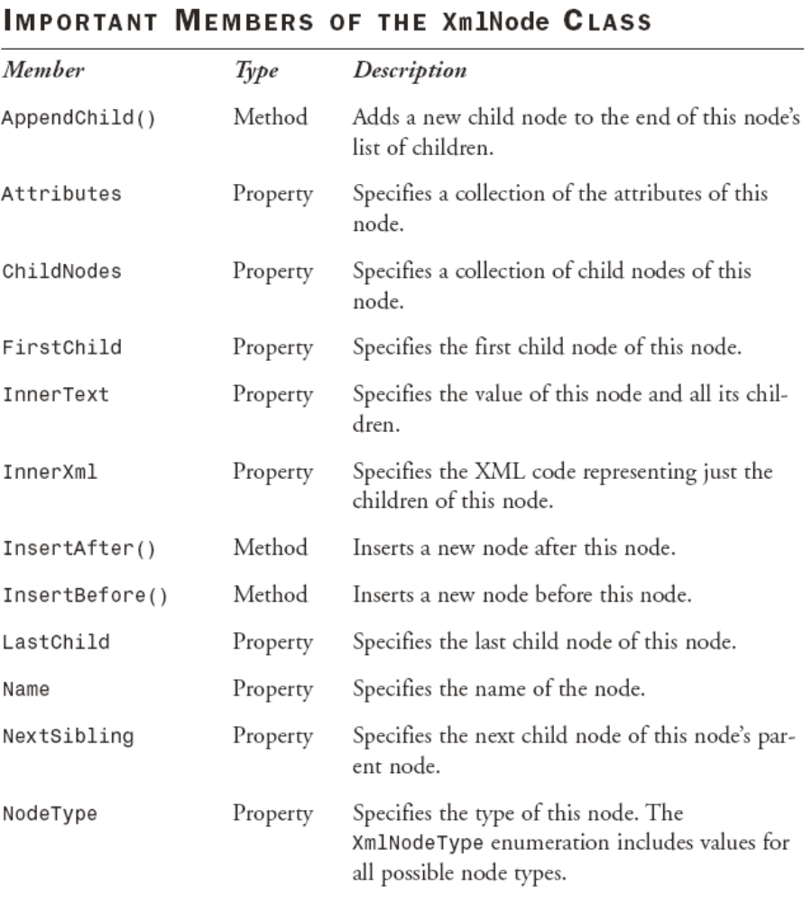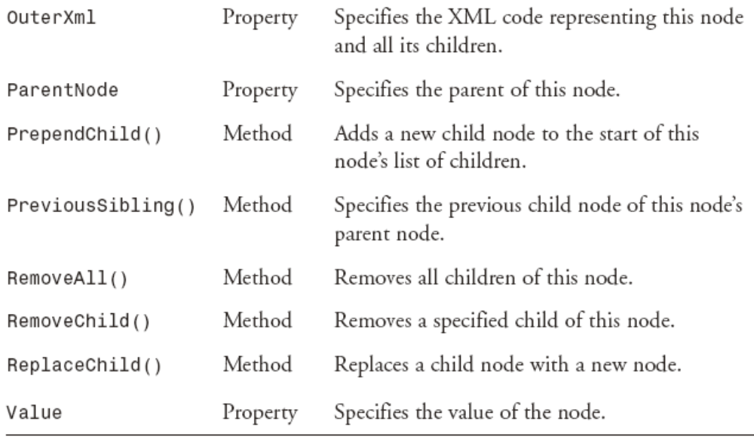

XmlNode objects are collected into an XmlDocument object. As you can probably guess, XmlDocument is the object in the System.Xml namespace that represents an entire XML document. The XmlDocument class provides an in-memory representation of an XML document.
The XmlDocument class implements the W3C Document Object Model (DOM) Level 1 Core and the Core DOM Level 2 standards. The DOM provides a standard programming model for working with XML. The following table shows the most important members of the XmlDocument class.

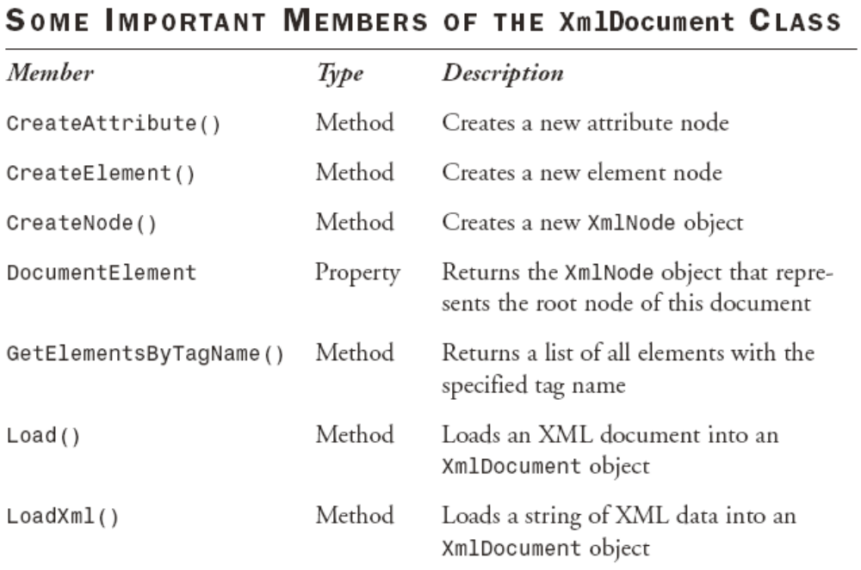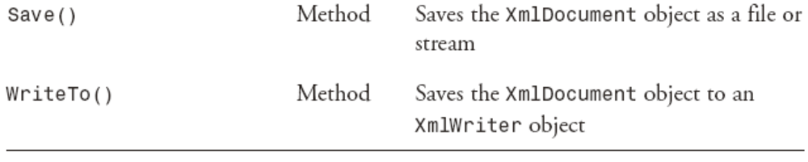

Lab 12: Displaying the Contents of an XML Document

1. Add a new form to your Visual C# .NET project.
2. Place a ListBox control (lbNodes) and a Button control (btnLoadXml) on the form.
3. Switch to the code view and add the following using directive:
using System.Xml;
4. Double-click the Button control and enter this code to load data when the button is clicked:
private void btnLoadXml_Click(object sender,
System.EventArgs e)
{
// Browse for an XML file
OpenFileDialog dlgOpen = new OpenFileDialog();
dlgOpen.Title = “Select a File”;
dlgOpen.Filter =
“XML files (*.xml)|*.xml|All Files(*.*)|*.*”;
if(dlgOpen.ShowDialog() == DialogResult.OK)
{
// Create an XmlTextReader object
// that will read in the file
XmlTextReader xtr = new XmlTextReader(
dlgOpen.FileName);
xtr.WhitespaceHandling = WhitespaceHandling.None;
// Create an XmlDocument object
XmlDocument xd = new XmlDocument();
// Load the file into the XmlDocument
xd.Load(xtr);
// Add an item representing the document
// to the ListBox
lbNodes.Items.Add(“XML Document”);
// Find the root node, and
// add it together with its children
XmlNode xnod = xd.DocumentElement;
AddWithChildren(xnod, 1);
}
}
private void AddWithChildren(
XmlNode xnod, Int32 intLevel)
{
// Adds a node to the ListBox, together with its
// children. intLevel controls the
// depth of indenting
XmlNode xnodWorking;
String strIndent = new String(‘ ‘, 2 * intLevel);
// Get the value of the node (if any)
String strValue= (String) xnod.Value;
if(strValue != null)
{
strValue = “ : “ + strValue;
}
// Add the node details to the ListBox
lbNodes.Items.Add(strIndent + xnod.Name + strValue);
// For an element node, retrieve the attributes
if(xnod.NodeType == XmlNodeType.Element)
{
XmlNamedNodeMap mapAttributes= xnod.Attributes;
// Add the attrbutes to the ListBox
foreach(XmlNode xnodAttribute in mapAttributes)
{
lbNodes.Items.Add(strIndent + “ “ +
xnodAttribute.Name + “ : “ +
xnodAttribute.Value);
}
// If there are any child nodes
// Call this procedure recursively
if(xnod.HasChildNodes)
{
xnodWorking = xnod.FirstChild;
while (xnodWorking != null)
{
AddWithChildren(
xnodWorking, intLevel + 1);
xnodWorking = xnodWorking.NextSibling;
}
}
}
}
5. Run the project. Click the button and browse to an XML file (for example, Customers.xml). The contents of the XML code are dumped to the ListBox control, as shown in Figure 12.
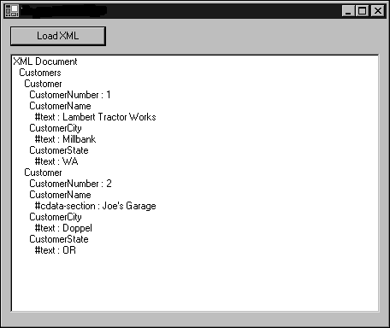
FIGURE 12
The XmlDocument class is an in-memory representation of an XML document.
As you can see in Figure 12, the object model implemented in the XmlDocument and XmlNode objects has access to the entire contents of the XML file. The code in Lab 12 uses an XmlTextReader object to read the disk file into the XmlDocument object. The XmlTextReader object has very similar functionality to the StreamReader and BinaryReader objects, except that it’s designed to pipe data from a disk file to an XmlDocument object. The XmlTextReader object also has other XMLspecific features. For example, the WhitespaceHandling property setting in the code in Lab 12 tells it not to create nodes for extra whitespace in the XML file.
The code uses the DocumentElement property of the XmlDocument object to find the node at the root of the tree representation of the XML document.
After that, it’s just a matter of recursively calling a procedure that adds information about the node to the ListBox control.
One bit of added complexity in the code is necessary to deal with attributes. Attribute nodes are not included in the ChildNodes collection of a node in the XmlDocument object. Instead, you can use the
Attributes property of the XmlNode object to get a collection of attribute nodes only. The code uses an XmlNamedNodeMap object to hold this collection; this object can hold an arbitrary collection of XmlNode objects of any type.
You can also modify an XML document through the XmlDocument object. To do so, you need to modify the individual XmlNode objects and then write the file back to disk.

Lab 13: Modifying an XML File by Using Code

1. Add a new form to your Visual C# .NET project.
2. Place a Button control (btnModify) on the form.
3. Switch to the code view and add the following using directive:
using System.Xml;
4. Double-click the Button control and enter this code to load and modify data when the button is clicked:
private void btnModify_Click(object sender,
System.EventArgs e)
{
// Browse for an XML file
OpenFileDialog dlgOpen = new OpenFileDialog();
dlgOpen.Title = “Select a File”;
dlgOpen.Filter =
“XML files (*.xml)|*.xml|All Files(*.*)|*.*”;
if(dlgOpen.ShowDialog() == DialogResult.OK)
{
// Create an XmlTextReader object
// that will read in the file
XmlTextReader xtr = new XmlTextReader(
dlgOpen.FileName);
xtr.WhitespaceHandling =
WhitespaceHandling.None;
// Create an XmlDocument object
XmlDocument xd = new XmlDocument();
// Load the file into the XmlDocument
xd.Load(xtr);
xtr.Close();
// Find the root node, and
// modify it together with its children
XmlNode xnod = xd.DocumentElement;
ModifyWithChildren(xnod);
// Write the modified file to disk
XmlTextWriter xtw = new XmlTextWriter(
dlgOpen.FileName + “.new”,
System.Text.Encoding.UTF8);
xd.WriteTo(xtw);
xtw.Flush();
xtw.Close();
MessageBox.Show(“Done!”);
}
}
private void ModifyWithChildren(XmlNode xnod)
{
XmlNode xnodWorking;
if (xnod.Name == “CustomerCity”)
{
// Sets all CustomerCity nodes to uppercase
xnod.FirstChild.Value =
xnod.FirstChild.Value.ToUpper();
}
// If there are any child nodes
// Call this procedure recursively
if (xnod.HasChildNodes)
{
xnodWorking = xnod.FirstChild;
while(xnodWorking != null)
{
ModifyWithChildren(xnodWorking);
xnodWorking = xnodWorking.NextSibling;
}
}
}
5. Run the project. Click the button and browse to an XML file. The code makes a copy of the XML file with the added extension .new. The copy has all the CustomerCity values converted to uppercase.
Writing the XML file in Lab 13 uses one new class, XmlTextWriter. This class connects an XmlDocument object to a backing store for output.

Treating XML as Relational Data

You can treat an XML document as relational data. To do this, you can use the XmlDataDocument class, which inherits from XmlDocument.
The key feature of the XmlDataDocument class is that it can be synchronized with a DataSet object.

Lab 14: Reading an XML Document into a DataSet Object

1. Add a new form to your Visual C# .NET project.
2. Place a Button control (btnLoadXml) and a DataGrid control (dgXml) on the form.
3. Switch to the code view and add the following using directives:
using System.Xml;
using System.Data;
4. Double-click the Button control and enter this code to load data when the button is clicked:
private void btnLoadXml_Click(object sender,
System.EventArgs e)
{
// Browse for an XML file
OpenFileDialog dlgOpen = new OpenFileDialog();
dlgOpen.Title = “Select a File”;
dlgOpen.Filter =
“XML files (*.xml)|*.xml|All Files(*.*)|*.*”;
if (dlgOpen.ShowDialog() == DialogResult.OK)
{
// Create an XmlTextReader object
// that will read in the file
XmlTextReader xtr = new XmlTextReader(
dlgOpen.FileName);
// Create an XmlDocument object
XmlDataDocument xdd = new XmlDataDocument();
// Get the DataSet
DataSet ds = xdd.DataSet;
// Read the schema of the file to
// initialize the DataSet
ds.ReadXmlSchema(xtr);
xtr.Close();
xtr = new XmlTextReader(dlgOpen.FileName);
xtr.WhitespaceHandling = WhitespaceHandling.None;
// Load the file into the XmlDataDocument
xdd.Load(xtr);
xtr.Close();
// And display it on the DataGrid
dgXml.DataSource = ds;
}
}
5. Run the project. Click the button and browse to an XML file. The code loads the XML file into the DataSet object and displays it on the user interface, as shown in Figure 13.

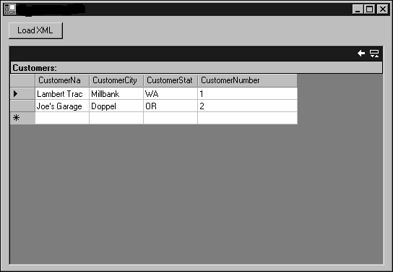
FIGURE 13
An XML File can be synchronized with a DataSet object, with the help of the XmlDataDocument class.

For the DataSet object to properly represent the XML code, it must have the same schema as the XML file. In Lab 13 I’ve ensured that by using the ReadXmlSchema() method of the DataSet object to load the schema from the same XML file that the XmlDataDocument object holds. The XmlTextReader object has to be closed and reopened after the schema is read because it’s a forwardonly object.
The synchronization between the XmlDataDocument object and the DataSet object is two way. If you derive a DataSet object from an XmlDataDocument object, modify the DataSet object, and then write the XmlDataDocument object back to disk, the changes that you made in the DataSet object are reflected in the XML file.

Lab 14:

Northwind Traders has a new European partner that doesn’t use Microsoft SQL Server for its data storage. However, it can import an XML file to its system. In this exercise, you need to retrieve all the customers from France, allow the user to edit the customer information on a form, and then save the edited version as an XML file.
The edits should not be saved to your own database.
How would you design such a form?
You should try working through this problem on your own first. If you get stuck, or if you’d like to see one possible solution, follow these steps:

1. Add a new form to your Visual C# .NET project.
2. Place a DataGrid control (dgCustomers) and a Button control (btnSave) on the form.
3. Switch to the code view and add the following using directives:
using System.Data;
using System.Data.SqlClient;
using System.Xml;
4. Double-click the form and enter this code to load the data when the form is opened:
private void Lab14_Load(
object sender,
System.EventArgs e)
{
// Create a SqlConnection
SqlConnection cnn = new SqlConnection(
“Data Source=(local);” +
“Initial Catalog=Northwind;" +
"Integrated Security=SSPI”);
// Create a SqlCommand
SqlCommand cmd = cnn.CreateCommand();
cmd.CommandType = CommandType.Text;
cmd.CommandText = “SELECT * FROM Customers “ +
“WHERE Country = ‘France’”;
// Set up the DataAdapter and fill the DataSet
SqlDataAdapter da = new SqlDataAdapter();
da.SelectCommand = cmd;
DataSet ds = new DataSet();
da.Fill(ds, “Customers”);
// Show the data on the user interface
// so that the user can edit it
dgCustomers.DataSource = ds;
dgCustomers.DataMember = “Customers”;
}

5. Double-click the Button control and enter this code to save the file when the user clicks the button:
private void btnSave_Click(object sender,
System.EventArgs e)
{
// Create an XmlDataDocument from the DataSet
XmlDataDocument xdd = new XmlDataDocument(
(DataSet) dgCustomers.DataSource);
// And save it to a disk file
XmlTextWriter xtw = new XmlTextWriter(
@”c:\temp\FranceCust.xml”,
System.Text.Encoding.UTF8);
xdd.WriteTo(xtw);
xtw.Flush();
xtw.Close();
MessageBox.Show(
@”Wrote file c:\temp\FranceCust.xml”);
}
6. Run the project. The French customers appear on the user interface. Edit some of the data and then click the Save button.
Open the c:\temp\FranceCust.xml file and verify that it contains the edited data.

